**User Acceptance Testing (UAT) Template**

|  |  |
| --- | --- |
| Date | 27 Jun 2025 |
| Team ID | LTVIP2025TMID58715 |
| Project Name | OrderOnTheGo: Your On-Demand Food Ordering Solution |
| Maximum Marks |  |

**Project Overview:**

Project Name: OrderOnTheGo: Your On-Demand Food Ordering Solution

Project Description: Introducing SB Foods, the cutting-edge digital platform poised to revolutionize the way you order food online. With SB Foods, your food ordering experience will reach unparalleled levels of convenience and efficiency.

Our user-friendly web app empowers foodies to effortlessly explore, discover, and order dishes tailored to their unique tastes. Whether you're a seasoned food enthusiast or an occasional diner, finding the perfect meals has never been more straightforward.

Imagine having comprehensive details about each dish at your fingertips. From dish descriptions and customer reviews to pricing and available promotions, you'll have all the information you need to make well-informed choices. No more second-guessing or uncertainty – SB Foods ensures that every aspect of your online food ordering journey is crystal clear.

The ordering process is a breeze. Just provide your name, delivery address, and preferred payment method, along with your desired dishes. Once you place your order, you'll receive an instant confirmation. No more waiting in long queues or dealing with complicated ordering processes – SB Foods streamlines it, making it quick and hassle-free.

**SCENARIO:**

**Late-Night Craving Resolution**

Meet Lisa, a college student burning the midnight oil to finish her assignment. As the clock strikes midnight, her stomach grumbles, reminding her that she skipped dinner. Lisa doesn't want to interrupt her workflow by cooking, nor does she have the energy to venture outside in search of food.

Solution with Food Ordering App:

1. Lisa opens the Food Ordering App on her smartphone and navigates to the late-night delivery section, where she finds a variety of eateries still open for orders.

2. She scrolls through the options, browsing menus and checking reviews until she spots her favorite local diner offering comfort food classics.

3. Lisa selects a hearty bowl of chicken noodle soup and a side of garlic bread, craving warmth and satisfaction in each bite.

4. With a few taps, she adds the items to her cart, specifies her delivery address, and chooses her preferred payment method.

5. Lisa double-checks her order details on the confirmation page, ensuring everything looks correct, before tapping the "Place Order" button.

6. Within minutes, she receives a notification confirming her order and estimated delivery time, allowing her to continue working with peace of mind.

7. As promised, the delivery arrives promptly at her doorstep, and Lisa eagerly digs into her piping hot meal, grateful for the convenience and comfort provided by the Food Ordering App during her late-night study session.

This scenario illustrates how a Food Ordering App caters to users' needs, even during unconventional hours, by offering a seamless and convenient solution for satisfying late-night cravings without compromising on quality or convenience.

**TECHNICAL ARCHITECTURE:**

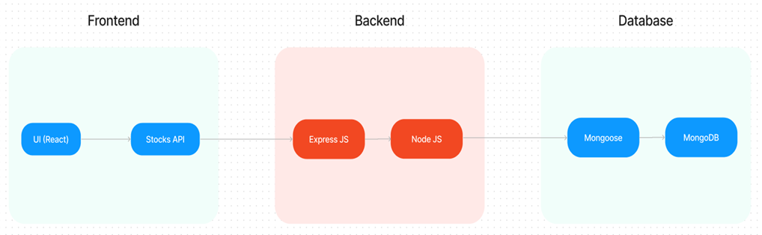

In this architecture diagram:

•        The frontend is represented by the "Frontend" section, including user interface components such as User Authentication, Cart, Products, Profile, Admin dashboard, etc.,

•        The backend is represented by the "Backend" section, consisting of API endpoints for Users, Orders, Products, etc., It also includes Admin Authentication and an Admin Dashboard.

•        The Database section represents the database that stores collections for Users, Admin, Cart, Orders, and products.

Project Version: [Version Number]

Testing Period: 14 Jun 2025 to 28 Jun 2025

**Testing Scope:**

User Registration and Login

* Menu Browsing and Dish Selection
* Order Placement and Confirmation
* Payment Integration
* Dashboard and Reporting (Admin/User)
* API Responses
* Form Validations
* Responsiveness (Mobile/Desktop)
  + As a user, I should be able to search for dishes
  + As a user, I should get order confirmation instantly
  + As an admin, I should view all placed orders and user stats

**Testing Environment:**

URL/Location: [Web URL or Application Location]

Credentials (if required): [Username/Password]

**Test Cases:**

|  |  |  |  |  |  |
| --- | --- | --- | --- | --- | --- |
| **Test Case ID** | **Test Scenario** | **Test Steps** | **Expected Result** | **Actual Result** | **Pass/Fail** |
| TC-001 | [Describe the scenario to be tested] | [Step 1]  [Step 2]  [Step 3] | [Describe the expected outcome] | [Record the actual outcome] | [Pass/Fail] |
| ... | ... | ... | ... | ... | ... |

**Bug Tracking:**

|  |  |  |  |  |  |
| --- | --- | --- | --- | --- | --- |
| **Bug ID** | **Bug Description** | **Steps to reproduce** | **Severity** | **Status** | **Additional feedback** |
| BG-001 | [Describe the issue or bug encountered] | [Step 1]  [Step 2]  [Step 3] | [Low/Medium/High] | [Open/In Progress/Closed] | [Any additional comments or feedback] |
| ... | ... | ... | ... | ... | ... |

**Sign-off:**

Tester Name: [Name of Tester]

Date: [Date of Test Completion]

Signature: [Tester's Signature]

**Notes:**

* Ensure that all test cases cover both positive and negative scenarios.
* Encourage testers to provide detailed feedback, including any suggestions for improvement.
* Bug tracking should include details such as severity, status, and steps to reproduce.
* Obtain sign-off from both the project manager and product owner before proceeding with deployment.